**Database management project : Normalization**

**Name : Siddhika Santoshkumar Bejekar**

**MIS no : 111803136**

**Project : Agri-market(Agriculture management system)**

**AGRI-MARKET**

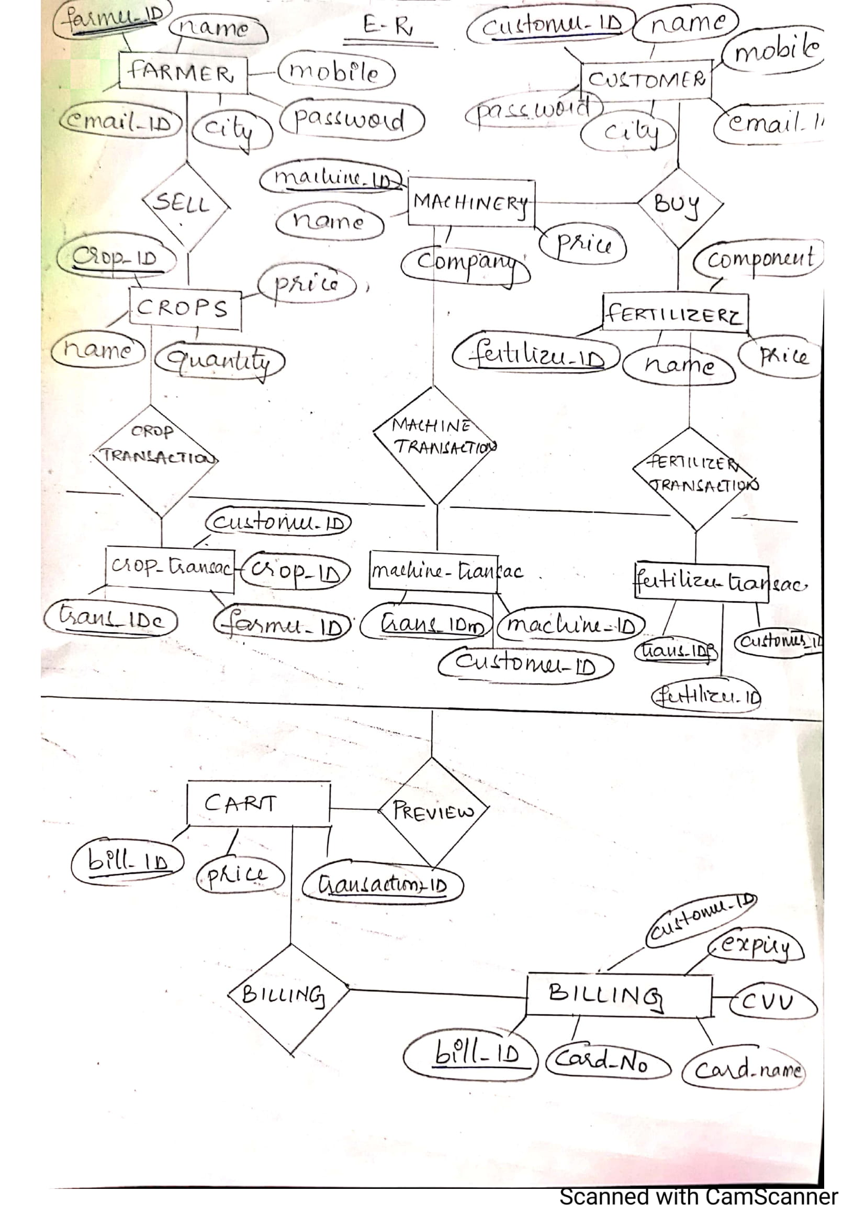

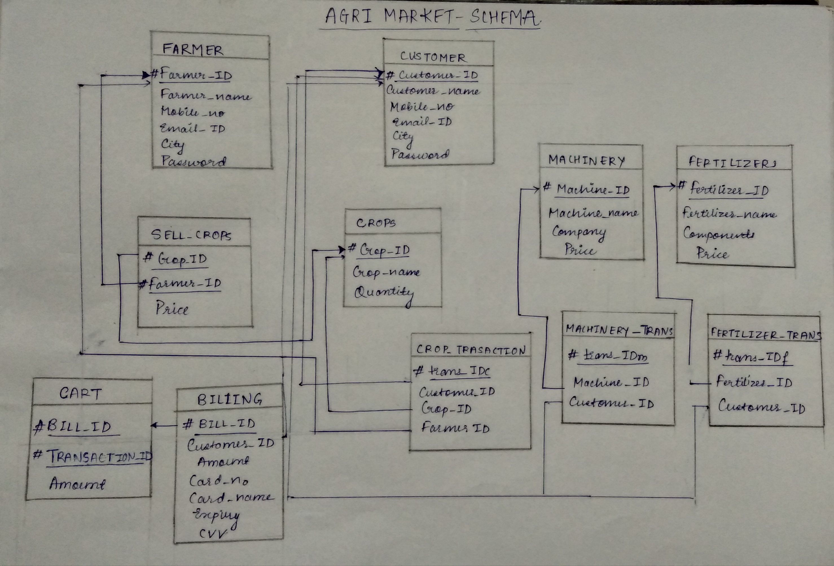

**Normalization:**

**1)Farmer table:**

|  |  |  |  |  |  |  |
| --- | --- | --- | --- | --- | --- | --- |
| **#Farmer_id** | **Username** | **Name** | **Mobile_no** | **Email** | **Address** | **password** |

**Primary key: Farmer_id**

**Functional dependencies:**

{Farmer_id}-> Name, Mobile_no, Email, Address, Username

{username}-> password

Thus, by transitive property of Functional dependencies,

Farmer_id-> password

Closure of Farmer_id:

(Farmer_id)+ : {Name, Mobile_no, Email, Address, username, password}

Candidate key : Farmer_id

Prime attributes : Farmer_id

Non-prime attributes : Name, Mobile_no, Email, Address, username, password

There is no partial dependency, hence the table is in Second Normal form.

Username is non-prime attribute and username->password. Thus, not in Third Normal Form.

Farmer table :

|  |  |  |  |  |  |
| --- | --- | --- | --- | --- | --- |
| **#Farmer_id** | **Username** | **Name** | **Mobile_no** | **Email** | **Address** |

Functional dependencies:

{Farmer_id}-> Name, Mobile_no, Email, Address, username

Username table for farmer:

|  |  |
| --- | --- |
| **#username** | **password** |

Functional dependency:

{username}->password

Now the tables are in Third Normal Form.

**2)Customer table:**

|  |  |  |  |  |  |  |
| --- | --- | --- | --- | --- | --- | --- |
| **#Customer_id** | **Name** | **Mobile_no** | **Email_id** | **Address** | **username** | **password** |

Primary key: Customer_id

**Functional dependencies:**

{Customer_id}-> Name, Mobile_no, Email, Address, username

{username}-> password

Thus, by transitive property of Functional dependencies,

Customer_id-> password

Closure of Customer_id:

(Customer_id)+ : {Name, Mobile_no, Email, Address, username, password}

Candidate key : Customer_id

Prime attributes : Customer_id

Non-prime attributes : Name, Mobile_no, Email, Address, username, password

There is no partial dependency, hence the table is in Second Normal form.

Username is non-prime attribute and username->password. Thus, not in Third Normal Form.

Customer table:

|  |  |  |  |  |  |
| --- | --- | --- | --- | --- | --- |
| **#Customer_id** | **username** | **Name** | **Mobile_no** | **Email** | **Address** |

Functional dependencies:

Customer_id->Name, Mobile_no, Email, Address, username

Username table for customer:

|  |  |
| --- | --- |
| **#Username** | **password** |

Functional dependency :

username->password

Now the tables are in Third Normal Form.

**Table for Products that can be sold by farmers and can be bought by customers :**

**The crops are sold by farmers on the site.**

**3)Crops table:**

|  |  |  |  |  |
| --- | --- | --- | --- | --- |
| **#Crop_id** | **#Farmer_id** | **Crop_name** | **Farmer_name** | **price** |

Primary key: {Crop_id, Farmer_id }

Foreign key : Farmer_id

**Functional dependencies:**

{Crop_id, Farmer_id}-> Price

{Crop_id}-> Crop_name

{Farmer_id}-> Farmer_name

{Crop_id, Farmer_id}-> Farmer_name, Crop_name, price

Thus, Candidate key : {Crop_id, Farmer_id}

Prime attributes : Crop_id, Farmer_id

Non-prime attributes : Farmer_name, Crop_name, price

There is partial dependency as Farmer_name is partially dependent on only farmer_id of candidate key and Crop_name dependent only on Crop_id.

Crop by farmers:

|  |  |  |
| --- | --- | --- |
| **#Crop_id** | **#Farmer_id** | **Price** |

Crops:

|  |  |
| --- | --- |
| **#Crop_id** | **Crop_name** |

Farmer selling crops:

|  |  |
| --- | --- |
| **#Farmer_id** | **Farmer_name** |

Now there is no partial dependency. The table is in Second Normal Form.

There are no Transitive functional dependencies. Thus, the tables are in Third Normal Form.

**The fertilizers and machine can be bought by farmers directly from the site.**

**4)Fertilizers table:**

|  |  |  |  |
| --- | --- | --- | --- |
| **#Fertilizer_id** | **Fertilizer** | **components** | **price** |

Primary key : Fertilizer_id

Functional dependencies:

{Fertilizer_id}->Fertilizer, components, price

There is no partial dependency, hence the table is in Second Normal form.

There are no transitive functional dependencies, thus it is in Third Normal Form.

**5)Machine table:**

|  |  |  |  |
| --- | --- | --- | --- |
| **#Machine_id** | **machine** | **Company** | **price** |

Primary key : Machine_id

Functional dependencies:

{Machine_id}->Machine, Company, Price

There is no partial dependency, hence the table is in Second Normal form.

There are no transitive functional dependencies, thus it is in Third Normal Form.

**Transaction tables:**

**6)Transaction table for buying crops:**

|  |  |  |  |  |  |  |
| --- | --- | --- | --- | --- | --- | --- |
| **#Transaction_id** | **Customer_id** | **Customer_name** | **Crop_id** | **Crop_name** | **Farmer_id** | **Farmer_name** |

Primary key : Transaction_id

Foreign keys: Customer_id, Crop_id, Farmer_id

Functional dependencies:

Transaction_id-> Crop_id, Cust_id, Farmer_id

Crop_id->Crop_name

Farmer_id->Farmer_name

Customer_id-> Customer_name

Thus, by the property of transitive dependency,

Transaction_id->Customer_id, Customer_name, Crop_id, Crop_name, Farmer_id,Farmer_name

Transaction_id is the candidate key

Prime attributes : Transaction_id

Non prime_attributes : Customer_id, Customer_name, Crop_id, Crop_name, Farmer_id,Farmer_name

There is partial dependency, so to convert to 2NF,

|  |  |  |  |
| --- | --- | --- | --- |
| **#Transaction_id** | **Customer_id** | **Crop_id** | **Farmer_id** |

Primary key: Transaction_id

FD: Transaction_id -> Customer_id, Crop_id, Farmer_id

There is no transitive dependency within this table.

|  |  |
| --- | --- |
| **#Customer_id** | **Customer_name** |

Primary key : Customer_id

FD : Customer_id-> Customer_name

|  |  |
| --- | --- |
| **#Crop_id** | **Crop_name** |

Primary key : Crop_id

FD: Crop_id-> Crop_name

|  |  |
| --- | --- |
| **#Farmer_id** | **Farmer_name** |

Primary key : Farmer_id

FD: Farmer_id-> Farmer_name

Thus, all the tables are in 2NF there are no transitive dependencies within any table. Thus, they are in Third normal form(3NF).

**7)Transaction table for buying fertilizers:**

|  |  |  |
| --- | --- | --- |
| **#Fertilizer_trans_id** | **Fertilizer_id** | **Farmer_id** |

Primary key : Fertilizer_trans_id

Foreign keys: Farmer_id, Fertilizer_id

Functional dependencies:

Fertilizer_trans_id -> Fertilizer_id, Farmer_id

**8)Transaction table for buying machinery:**

|  |  |  |
| --- | --- | --- |
| **#Machine_trans_id** | **Machine_id** | **Farmer_id** |

Primary key : Machine_trans_id

Foreign keys: Farmer_id, Machine_id

Functional dependencies:

Machine_trans_id -> Machine_id, Farmer_id